Unleash the Power of CodeWhisper: AWS's Secret Weapon for Effective Communication

# Introduction

In the rapidly evolving world of cloud computing, Amazon Web Services (AWS) continues to introduce groundbreaking tools and services that empower developers, architects, and operations teams to thrive in the cloud. One such hidden gem in the AWS arsenal is CodeWhisper. While it may not enjoy the same level of public attention as some of its counterparts, CodeWhisper is a powerful suite of communication and collaboration tools, designed to transform the way teams work together in the AWS environment.

CodeWhisperer is trained on billions of lines of code and can generate code suggestions ranging from snippets to full functions in real time based on your comments and existing code. Bypass time-consuming coding tasks and accelerate building with unfamiliar APIs

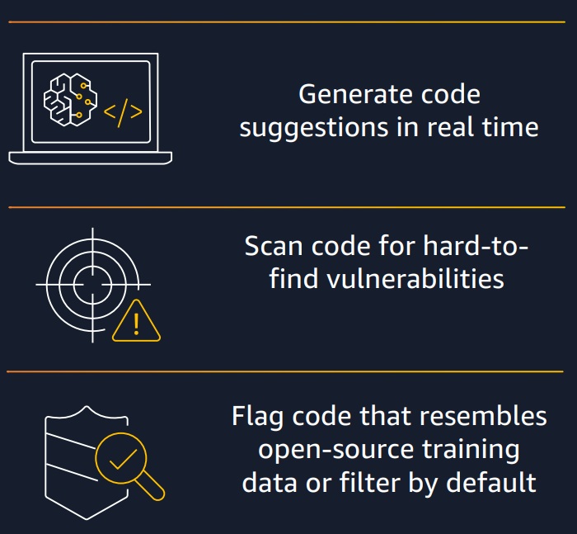In the ever-evolving landscape of cloud computing, Amazon Web Services (AWS) has consistently been at the forefront of innovation. Among the vast array of tools and services that AWS provides, there's one that often flies under the radar but plays a crucial role in optimizing cloud workflows and facilitating seamless communication - CodeWhisper.

CodeWhisper is AWS's answer to the challenges faced by development teams in large-scale cloud projects. This blog post will delve into the depths of CodeWhisper, exploring its key features, architecture, and its indispensable role in modern cloud application development.

# Understanding Code Whisper

CodeWhisper is not a standalone service, but rather an umbrella term encompassing a suite of tools and best practices aimed at improving communication and collaboration among development and operations teams. Its primary goal is to foster synergy between these traditionally siloed teams, enabling them to work together efficiently in the AWS environment.

**Key Features of CodeWhisper**

1. Real-time Communication: CodeWhisper offers real-time chat and video conferencing features through Amazon Chime. This ensures that team members can communicate seamlessly, discuss issues, and share insights without leaving their AWS environment.
2. Collaborative Coding: AWS Cloud9, a powerful cloud-based integrated development environment, is an integral part of CodeWhisper. It allows developers to collaboratively write, run, and debug code, even if they are geographically dispersed. This feature promotes better teamwork and faster code development.
3. Documentation and Knowledge Sharing: CodeWhisper encourages the creation and sharing of documentation through AWS Wikis and Amazon WorkDocs. This feature ensures that vital project information is always accessible to team members, fostering knowledge transfer.
4. Integrated CI/CD: CodeWhisper promotes the use of AWS CodePipeline and AWS CodeBuild, ensuring a streamlined process for continuous integration and continuous delivery. This results in faster development cycles and more robust deployment processes.

# CodeWhisper Architecture

To better understand how CodeWhisper works, let's take a look at its underlying architecture:

CodeWhisper Architecture Diagram

1. User Interface (UI): The front-end component of CodeWhisper is the user interface, where developers and operators can access all the tools and features. It includes a dashboard for tracking project progress, a chat interface, and collaborative coding environments.
2. Real-time Communication: CodeWhisper relies on Amazon Chime for real-time chat and video conferencing. Amazon Chime provides secure, scalable, and reliable communication tools, essential for team collaboration.
3. Collaborative Coding: AWS Cloud9 serves as the heart of collaborative coding. It offers code editing, debugging, and a seamless environment for multiple developers to work together, thereby reducing development time and improving code quality.
4. Documentation and Knowledge Sharing: Documentation tools such as AWS Wikis and Amazon WorkDocs store essential project information and allow easy sharing. This knowledge-sharing aspect is crucial in keeping teams on the same page.
5. CI/CD Integration: AWS CodePipeline and AWS CodeBuild are tightly integrated into CodeWhisper, ensuring that the code is tested, built, and deployed continuously. This promotes a DevOps culture and reduces the manual intervention required for the deployment process.

# In-Depth Discussion

## Setting Up the Code Whisperer

**Choosing your IDE**

CodeWhisperer acts as an enhancement to certain integrated development environments (IDEs).

1. Amazon SageMaker notebooks serve as an essential component of the SageMaker Studio interactive development environment, offering a managed JupyterLab environment to create, share, and collaborate on Jupyter notebooks. Designed to support machine learning workflows within AWS, Studio Notebooks provide built-in version control and collaboration functionalities. They facilitate integration with SageMaker and other AWS services, allowing users to build, train, and deploy models directly from their notebooks. Additionally, SageMaker Studio notebooks automatically scale underlying resources according to workload requirements, ensuring efficient resource utilization.
2. JupyterLab is an IDE that allows you to work with data and code in a flexible, open-source platform. With JupyterLab, you can create and edit Jupyter notebooks, run code in various programming languages, and visualize and manipulate data using a range of libraries and tools. JupyterLab is widely used in data science, machine learning, and scientific research, and is supported by a vibrant community of contributors and users.
3. The AWS Toolkit for Visual Studio Code is an open source plug-in for Visual Studio Code that makes it easier to create, debug, and deploy applications on Amazon Web Services. With the AWS Toolkit for Visual Studio Code, you will be able to get started faster and be more productive when building applications with Visual Studio Code on AWS. The toolkit provides an integrated experience for developing serverless applications, including assistance for getting started, ML-powered code recommendations, step-through debugging, and deploying from the IDE.
4. The AWS Toolkit for JetBrains is an open source plug-in for the IDEs from JetBrains that makes it easier for developers to develop, debug, and deploy serverless applications that use Amazon Web Services. It includes features like credentials management and AWS Region management that simplify writing applications for Amazon Web Services.
5. AWS Cloud9 is a cloud-based IDE that lets you write, run, and debug your code with just a browser. It includes a code editor, debugger, and terminal. AWS Cloud9 comes prepackaged with essential tools for popular programming languages, including JavaScript, Python, and PHP.
6. AWS Lambda is a serverless, event-driven compute service that lets you run code for virtually any type of application or backend service without provisioning or managing servers. You can trigger Lambda from over 200 AWS services and software as a service (SaaS) applications, and only pay for what you use.

## Typical Coding Workflow

The typical coding workflow of CodeWhisper in AWS is designed to streamline communication, collaboration, and the development process for development and operations teams.

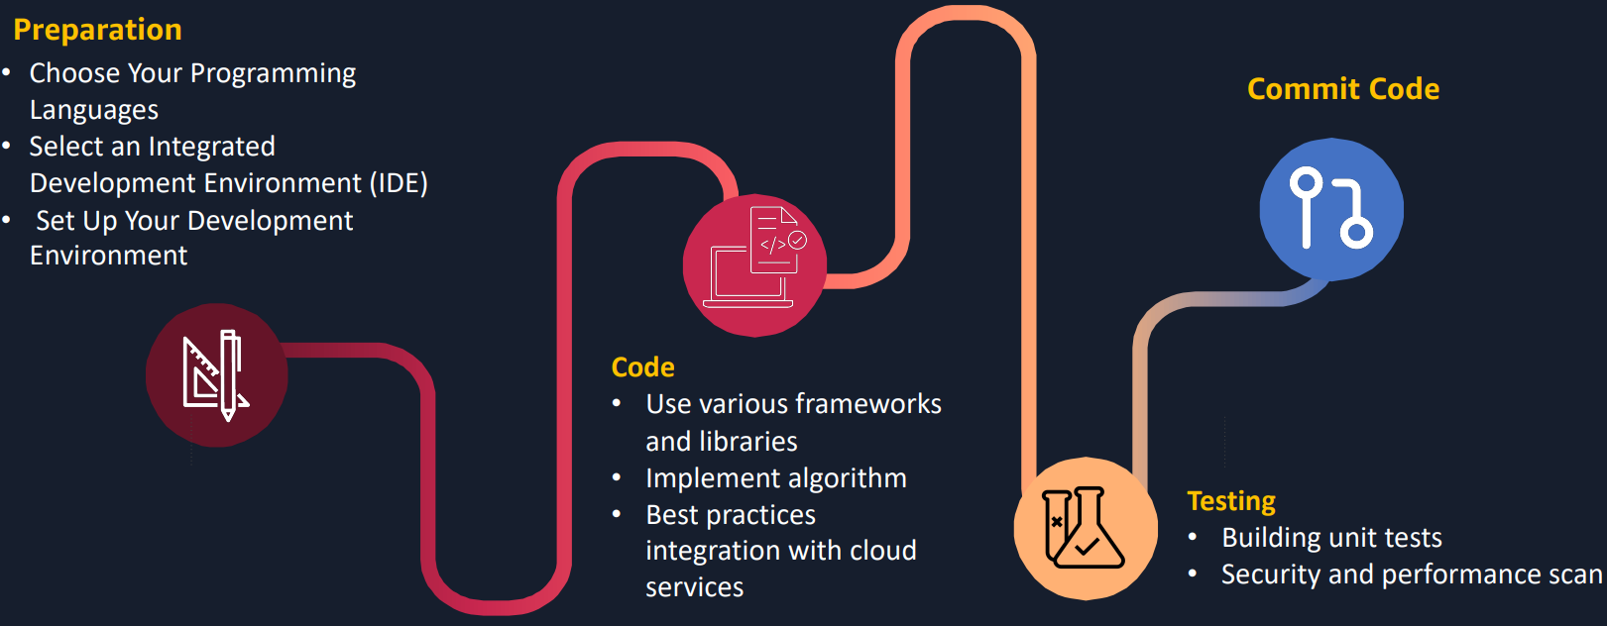

1. Real-Time Communication:

Chat and Discussion: Team members initiate discussions and communicate in real time using the integrated chat and video conferencing features provided by Amazon Chime, a component of CodeWhisper. They can discuss project requirements, share ideas, and clarify doubts, fostering effective communication among geographically dispersed team members.

1. Collaborative Coding:
   1. Code Development: Developers access AWS Cloud9, an integrated development environment, through the CodeWhisper interface. Multiple team members can collaboratively write, edit, and test code in real time. This collaborative coding environment eliminates the need for developers to work in isolation and encourages teamwork.
   2. Code Versioning: CodeWhisper integrates with AWS CodeCommit, a source code management service. Developers can use CodeCommit to version control their code, ensuring that changes are tracked, and rollbacks are possible if needed.
2. Documentation and Knowledge Sharing:
   1. Documentation Creation: Developers and other team members create and update project documentation using AWS Wikis and Amazon WorkDocs, which are part of the CodeWhisper suite. This documentation can include project specifications, architecture diagrams, coding standards, and other vital information.
   2. Knowledge Transfer: Team members can easily share and access project documentation, ensuring that knowledge is transferred effectively. This promotes a shared understanding of project details and reduces the chances of miscommunication.
3. Continuous Integration and Continuous Delivery (CI/CD):
   1. Code Integration: Developers commit their code changes to AWS CodeCommit, which automatically triggers AWS CodePipeline, a continuous integration and continuous delivery (CI/CD) service. CodePipeline orchestrates the building, testing, and deployment processes.
   2. Build and Testing: AWS CodeBuild, an integral part of the CI/CD pipeline, compiles and tests the code. It ensures that code changes are thoroughly examined for issues and compatibility.
   3. Deployment: CodePipeline deploys the code to the specified AWS environment, whether it's for development, staging, or production. This automation minimizes the risk of human error during deployment and speeds up the release process.
4. Monitoring and Feedback:
   1. Monitoring: AWS offers a range of monitoring and logging tools like Amazon CloudWatch and AWS X-Ray to monitor the deployed application. These tools help identify performance issues and errors in real time.
   2. Feedback Loop: The feedback loop is an essential part of the workflow. Any issues or errors detected during the monitoring phase are reported back to the development team via CodeWhisper's real-time chat. This feedback allows developers to quickly address and resolve issues, maintaining the application's quality.
5. Iteration and Optimization:
   1. Iterative Process: The workflow is iterative, and as new features or improvements are planned, the team goes back to the collaborative coding phase, creating a continuous cycle of development and optimization.
6. Review and Approval:
   1. Code Review: Code changes go through a review process within the team, ensuring that coding standards and best practices are followed.
   2. Approval: Once the code changes are reviewed and approved, they can be merged into the main codebase and included in the next deployment cycle.

## Coding Faster with Code Whisperer

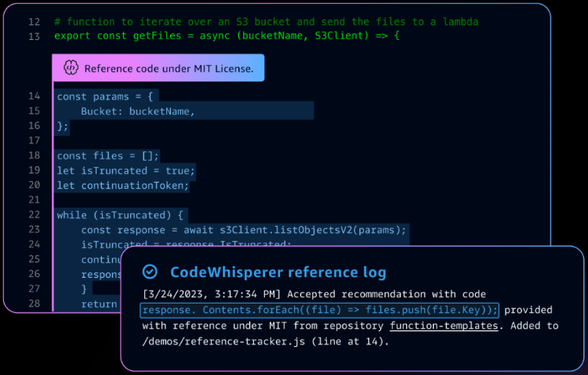 CodeWhisperer can flag or filter code suggestions that resemble open-source training data. Get the associated open-source project’s repository URL and license so that you can more easily review them and add attribution

CodeWhisper's significance lies in bridging the communication gap that often hampers cloud development projects. By providing a unified platform for real-time communication, collaborative coding, and knowledge sharing, it ensures that everyone involved in the project has access to the right information at the right time.

## Key Advantages of Code Whisper

One of the key advantages of CodeWhisper is its ability to break down traditional silos. Developers, operations teams, and other stakeholders can collaborate seamlessly, resulting in improved code quality and accelerated project timelines. The integrated CI/CD pipeline ensures that the code is continuously tested and deployed, reducing the risk of errors in production.

1. Scalability: Discuss how CodeWhisper's architecture and integration with AWS services allow for scalability in communication and development as projects grow.
2. Security: Highlight the security features, encryption methods, and access controls that ensure the confidentiality and integrity of communication and documentation within CodeWhisper.
3. Performance Optimization: Address technical strategies for optimizing the performance of collaborative coding and CI/CD processes within CodeWhisper, including resource allocation and parallel processing.
4. API Integration: Explain the potential for custom API integrations with CodeWhisper, enabling further customization and extensibility for specific project requirements.

Conclusion

In the fast-paced world of cloud computing, CodeWhisper emerges as a vital asset for development and operations teams. It brings together the necessary tools and features required for effective communication, collaborative coding, and knowledge sharing. This holistic approach to cloud application development ensures that projects are delivered faster, with improved quality and fewer hiccups along the way.

As AWS continues to evolve and innovate, CodeWhisper stands as a shining example of how technology can streamline and enhance teamwork, ultimately leading to better products and services in the cloud. It's high time that development teams consider the power of CodeWhisper to unlock their full potential in the AWS ecosystem.